Assignment API

Q1. What is an API? Give an example, where an API is used in real life.

An API, or Application Programming Interface, is a set of rules and protocols that allows different software applications to communicate with each other. APIs enable applications to request and exchange data or functionality seamlessly, without requiring users to manually input information from one application to another.

**Example of API in Real Life:**

A common real-life example of an API is when you use a third-party service like Google Maps within another app, such as a food delivery or ride-sharing app. When you order a ride on Uber, the app uses the Google Maps API to display a map showing the driver’s location and the route to the destination. The Uber app doesn’t need to create its own mapping system; instead, it integrates Google Maps through the API, allowing it to use map data, route information, and location services directly within the app.

Q2. Give advantages and disadvantages of using API.

**Advantages of Using APIs:**

1. **Enhanced Efficiency**: APIs streamline the integration process between systems, reducing development time and improving functionality without reinventing the wheel.
2. **Scalability**: APIs enable applications to scale and expand their functionality by easily integrating third-party services.
3. **Automation**: APIs allow different software systems to interact with minimal human intervention, which helps automate processes and save time.
4. **Improved User Experience**: APIs enable applications to access advanced features, such as payment gateways or location-based services, which enhance the user experience.
5. **Data and Function Sharing**: APIs enable seamless sharing of data and functions between applications, creating a more connected and versatile ecosystem.

**Disadvantages of Using APIs:**

1. **Security Risks**: Exposing APIs to external users can introduce security vulnerabilities if not implemented with strong authentication and security measures.
2. **Dependency on External Services**: If an API from a third-party provider experiences downtime or changes its structure, it can disrupt dependent applications.
3. **Limited Control**: Since APIs are often provided by third parties, developers have limited control over changes, such as updates or feature removals, which can impact their applications.
4. **Complexity in Integration**: While APIs simplify data sharing, setting them up initially and maintaining them can require complex configurations and extensive testing.
5. **Cost**: Many third-party APIs, such as cloud or analytics services, may have associated usage costs, which can increase expenses over time.

Q3. What is a Web API? Differentiate between API and Web API.

A **Web API** is a specific type of API designed to facilitate communication between applications over the web, typically through HTTP requests. Web APIs are commonly used to enable web-based applications to interact with each other, such as by fetching data from a server or connecting with cloud services.

**Differences Between API and Web API:**

|  |  |  |
| --- | --- | --- |
| **Aspect** | **API** | **Web API** |
| **Definition** | A general set of protocols for application interaction. | A type of API specifically designed to work over the web via HTTP/HTTPS. |
| **Communication** | Can work over various protocols, such as HTTP, TCP/IP, or within the same system. | Exclusively communicates over web-based protocols like HTTP/HTTPS. |
| **Platform Dependence** | Can operate across different platforms or within the same environment (e.g., OS-level APIs). | Primarily platform-independent and used for web applications. |
| **Accessibility** | May require installation on specific platforms or devices. | Accessible via a web browser or through HTTP requests. |
| **Example** | Operating System APIs (e.g., Windows API, Android API) | RESTful API, such as Twitter’s API or Google Maps API. |

While both APIs and Web APIs allow applications to communicate, Web APIs specifically use web protocols (HTTP/HTTPS) to facilitate communication, making them ideal for connecting web-based applications and cloud services across the internet.

Q4. Explain REST and SOAP Architecture. Mention shortcomings of SOAP.

**REST Architecture**

**REST (Representational State Transfer)** is an architectural style for designing networked applications. It uses HTTP methods (such as GET, POST, PUT, DELETE) to perform CRUD (Create, Read, Update, Delete) operations. REST is stateless, meaning each request from a client to a server must contain all the information needed to understand and process the request. It is widely used in modern web APIs due to its simplicity, flexibility, and performance.

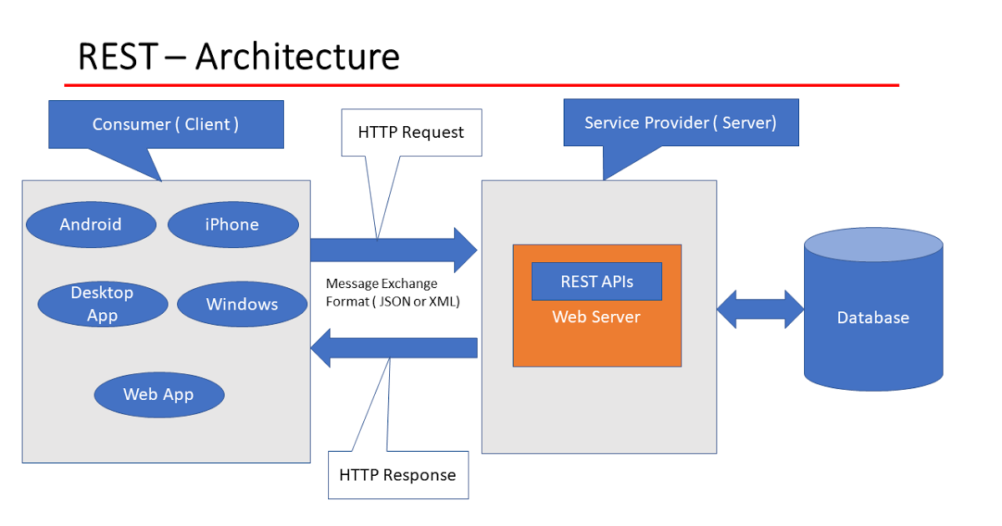

Key Characteristics of REST:

* **Stateless**: Each request is independent, containing all the necessary information.
* **Resource-Based**: Uses URIs to identify resources (e.g., /users/123).
* **HTTP Methods**: Uses standard HTTP verbs (GET, POST, PUT, DELETE) to perform operations on resources.
* **Scalability**: REST services are lightweight, making them ideal for scaling across distributed systems.
* **Data Formats**: Primarily uses JSON but can also support XML and other formats.

**SOAP Architecture**

**SOAP (Simple Object Access Protocol)** is a protocol for exchanging structured information in web services, using XML as the message format. SOAP relies on a strict set of standards and specifications, which include security and transaction compliance, making it suitable for complex enterprise-level applications requiring high security and reliable message delivery.

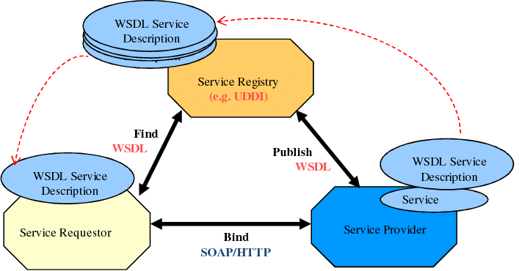

Key Characteristics of SOAP:

* **Protocol-Based**: SOAP has its own standards and rules for messaging.
* **XML-Based**: Only supports XML for message format.
* **Stateful or Stateless**: Can be used as either stateful or stateless.
* **Security**: Provides built-in protocols for security, like WS-Security.
* **Error Handling**: Has standardized error handling via SOAP fault messages.
* **Transport Protocol**: Primarily uses HTTP/HTTPS but can also work with other protocols (e.g., SMTP, TCP).

**Shortcomings of SOAP:**

1. **Complexity**: SOAP’s rigid standards and reliance on XML make it more complex to set up and maintain than REST.
2. **Performance**: The XML message format makes SOAP slower and more resource-intensive, which can impact performance, especially on limited bandwidth.
3. **Limited Data Format Support**: SOAP exclusively supports XML, whereas REST can use JSON, XML, and other formats.
4. **Less Flexible**: SOAP’s strict protocols and structure make it less adaptable and harder to integrate with simpler applications compared to REST.
5. **Higher Bandwidth Usage**: SOAP’s verbose XML structure results in larger message sizes, consuming more bandwidth than REST’s typically lean JSON format.

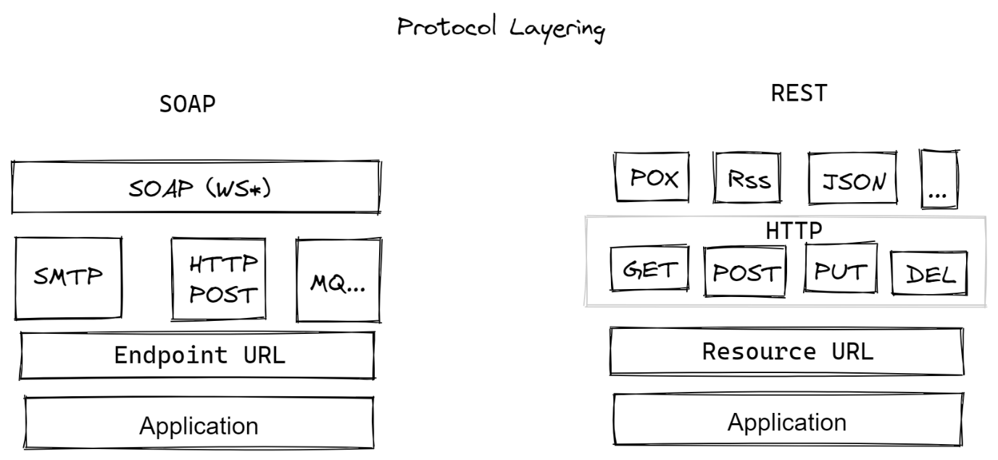

In summary, REST is preferred for simpler, scalable applications, while SOAP remains valuable for enterprise-level applications where security, reliability, and formal contracts are essential.

Q5. Differentiate between REST and SOAP.

Difference between REST and SOAP :

|  |  |  |
| --- | --- | --- |
| **Feature** | **REST (Representational State Transfer)** | **SOAP (Simple Object Access Protocol)** |
| **Architecture Type** | Architectural style | Protocol-based |
| **Communication Protocol** | Primarily HTTP/HTTPS | Can use multiple protocols (HTTP, SMTP, TCP) |
| **Message Format** | Typically JSON (also supports XML, HTML, etc.) | Exclusively XML |
| **Statelessness** | Stateless | Can be stateless or stateful |
| **Flexibility** | Highly flexible and scalable | Less flexible, rigid standards |
| **Ease of Use** | Simple to use and implement | More complex, with strict specifications |
| **Performance** | Generally faster and more lightweight | Slower due to XML parsing and processing overhead |
| **Data Transfer Efficiency** | Lightweight messages, smaller in size | Verbose XML, resulting in larger message sizes |
| **Security** | Uses HTTPS for security; additional security may require custom implementation | Built-in security (WS-Security) for complex needs |
| **Reliability** | Suitable for simple, reliable applications | Highly reliable, supports ACID compliance |
| **Error Handling** | Uses standard HTTP status codes for errors | Has specific error handling (SOAP fault messages) |
| **Use Case Suitability** | Ideal for web and mobile applications, microservices | Best for enterprise applications needing formal contracts and high security |

REST is ideal for simpler, faster, and more flexible web services, commonly used in mobile and web applications. SOAP is preferred in enterprise environments requiring strict security, transaction management, and reliable messaging.